NOT A BOX
PAS-DU-TOUT-UN-CARTON
Antionette Portis

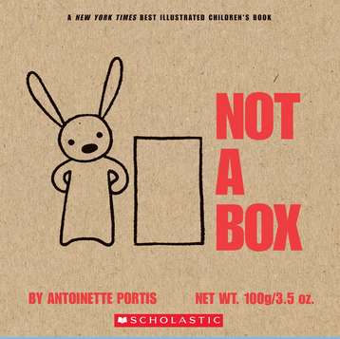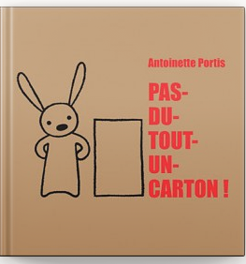

Activity:
• Listen to Mrs. Ross read the story.
• Create something out of any size box.
• Bonus: Write about your Not-A-Box. You may want to think about the following questions when writing. Where did you get your ideas for your Not-A-Box? What materials did you use? How did you make your box? Does your box have special features?
• Option: Send a picture of your writing and/or your creation to your teacher or to Mrs. Ross (lross@sd44.ca).

Click here for the English read aloud.

Click here for the French read aloud.

