Spine Poetry Quarantine Challenge!

Step 1: Browse many, many book spines and choose one or two that spark your interest or that speak to your heart.
Step 2: Find other book spines that complement your first choice. Don’t edit yet –grab any spines that you think may work! Stop when you have 6-8 books.
Step 3: Start playing with combinations of spines, swapping and changing the order. Don’t settle with your first try! Try putting your poem together like a puzzle and explore how changing the order changes the meaning of your poem.
Step 4: Read your poem aloud to yourself and to a family member. When it sounds right, snap a photo of your completed poem, send it to Mrs. Ross at lross@sd44.ca.
For more information, see the below link.

https://www.poetry4kids.com/news/how-to-create-book-spine-poetry/

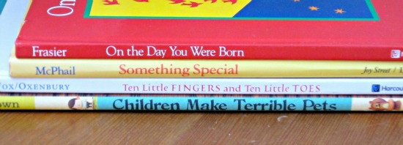

Thanks to Mrs. Danelli for the lesson plan!

